**Lab – 6**

1. **Create the following two tables (EMP and DEPT)**

**EMP TABLE**

**EMPNO      ENAME       JOB                MGR          HIREDATE          SAL         COMM           DEPTNO**

**----------      ----------      ---------            ----------        --------- ---------- ---------- ----------**

**7369           SMITH       CLERK             7902            17-DEC-80            500           800                  20**

**7499          ALLEN       SALESMAN     7698            20-FEB-81           1600           300                 30**

**7521          WARD        SALESMAN      7698           22-FEB-81           1250          500                  30**

**7566           JONES       MANAGER        7839           02-APR-81          2975                                  20**

**7654          MARTIN     SALESMAN      7698           28-SEP-81           1250          1400                30**

**7698          BLAKE       MANAGER        7839          01-MAY-81         2850                                  30**

**7782          CLARK       MANAGER        7839          09-JUN-81          2450                                   10**

**7788       SCOTT        ANALYST         7566              09-DEC-82       3000                                    20**

**7839       KING           PRESIDENT                           17-NOV-81       5000                                    10**

**7844       TURNER     SALESMAN       7698            08-SEP-81         1500            0                      30**

**7876       ADAMS       CLERK               7788            12-JAN-83         1100                                   20**

**7900       JAMES         CLERK               7698            03-DEC-81        950                                     30**

**7902       FORD           ANALYST         7566            03-DEC-81        3000                                   20**

**7934      MILLER        CLERK              7782             23-JAN-82        1300                                   10**

**DEPT TABLE**

**DEPTNO                  DNAME                   LOC**

**----------                  --------------                -------------**

**10                      ACCOUNTING            NEW YORK**

**20                      RESEARCH                 DALLAS**

**30                      SALES                          CHICAGO**

**40                      OPERATIONS             BOSTON**

create table emp ( empno int(4), ename varchar(10), job varchar(9), mgr int(4), hiredate date, sal decimal(7,2), comm decimal(7,2), deptno int(2) );

insert into emp values (7369, 'SMITH', 'CLERK', 7902, '1980-12-17', 500, 800, 20); insert into emp values (7499, 'ALLEN', 'SALESMAN', 7698, '1981-02-20', 1600, 300, 30); insert into emp values (7521, 'WARD', 'SALESMAN', 7698, '1981-02-22', 1250, 500, 30); insert into emp values (7566, 'JONES', 'MANAGER', 7839, '1981-04-02', 2975, null, 20); insert into emp values (7654, 'MARTIN', 'SALESMAN', 7698, '1981-09-28', 1250, 1400, 30); insert into emp values (7698, 'BLAKE', 'MANAGER', 7839, '1981-05-01', 2850, null, 30); insert into emp values (7782, 'CLARK', 'MANAGER', 7839, '1981-06-09', 2450, null, 10); insert into emp values (7788, 'SCOTT', 'ANALYST', 7566, '1982-12-09', 3000, null, 20); insert into emp values (7839, 'KING', 'PRESIDENT', null, '1981-11-17', 5000, null, 10); insert into emp values (7844, 'TURNER', 'SALESMAN', 7698, '1981-09-08', 1500, 0, 30); insert into emp values (7876, 'ADAMS', 'CLERK', 7788, '1983-01-12', 1100, null, 20); insert into emp values (7900, 'JAMES', 'CLERK', 7698, '1981-12-03', 950, null, 30); insert into emp values (7902, 'FORD', 'ANALYST', 7566, '1981-12-03', 3000, null, 20); insert into emp values (7934, 'MILLER', 'CLERK', 7782, '1982-01-23', 1300, null, 10);

create table dept ( deptno int(2), dname varchar(14), loc varchar(13) );

insert into dept values (10, 'ACCOUNTING', 'NEW YORK'); insert into dept values (20, 'RESEARCH', 'DALLAS'); insert into dept values (30, 'SALES', 'CHICAGO'); insert into dept values (40, 'OPERATIONS', 'BOSTON');

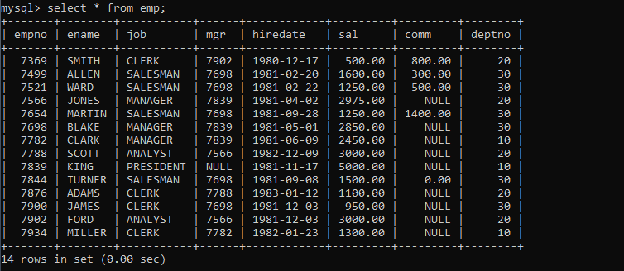

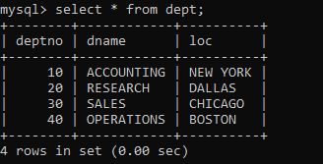

**Write the Queries for the following using In-built functions.**

1. **Retrieve average salary of all employees.**

select avg(sal) from emp;

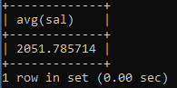

1. **Retrieve the number of employees.**

select count(*) from emp;

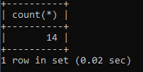

1. **Retrieve distinct number of employee.**

select count(distinct ename) from emp;

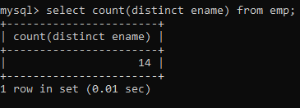

1. **Retrieve total salary of employee group by job.**

select sum(sal) from emp group by job;

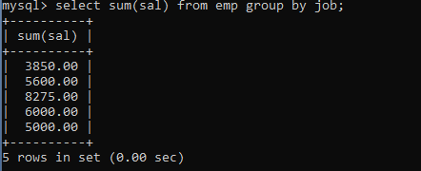

1. **Display the employee information with maximum salary.**

select * from emp where sal = (select max(sal) from emp where sal < (select max(sal) from emp));

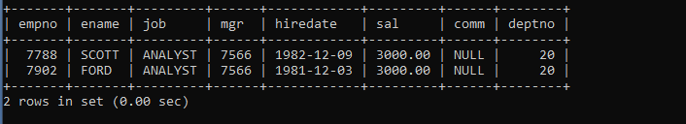

1. **Find the highest paid employee in department 10.**

select ename, sal from emp where deptno = 10 order by sal desc limit 1;

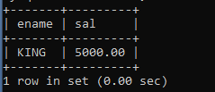

1. **List the emps whose sal is equal to the average of max and minimum.**

select * from emp where sal = (select (max(sal) + min(sal)) / 2 from emp);



1. **List the emps who joined in the company on the same date.**

select * from emp e where hiredate in (select hiredate from emp where empno <> e.empno);

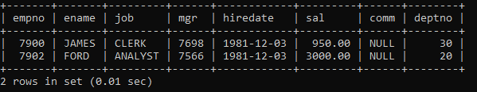

1. **Display the employee names in upper and lower case.**

select upper(ename), lower(ename) from emp;

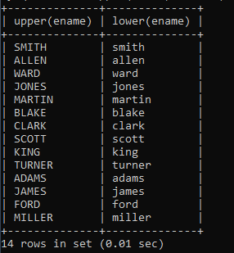

1. **find the date of 3 days later from hiredate.**

select ename, hiredate, date_add(hiredate, interval 3 day) as hiredate_plus_3_days from emp;

